MEETING OF

FINMERE PARISH COUNCIL

Minutes of meeting held on 28th April 2020 remotely via Zoom

Present:- Councillors, Mike Kerford-Byrnes (MKB) (Chairman), Katherine Grimston (KG) (Vice Chairman), Mike Kirby (MK), Steve Trice (ST), Peter Goss (PG), Joanne Brooks (JB) and Tim Ayling (TA)

In attendance:- District Councillor Barry Wood (BW) and Sharron Chalcraft (SC) (Parish Clerk and RFO)

1. APOLOGIES (19.31)

No apologies were received

2. DECLARATIONS OF INTEREST AND INVOLVEMENT (19.32)

ST declared an involvement in issues involving the Village Hall Management Committee (VHMC) and all Councillors declared an involvement in the village hall planning application, addressed in Section 17 below.

3. MINUTES (19.33)

The minutes of the meetings of 3rd and 24th of March 2020 were approved with corrections.

4. MATTERS ARISING (19.34)
4.01 Sports Pavilion Issues There can be no meetings with the Sports Club at the moment. They have been unable to make their repayment of £200 on the loan before March 31st as two signatures are needed on their cheques and they are unable to meet up or access the cheque book. Also, they are probably going to have a problem paying the £600 grass cutting contribution as all sport has been suspended and there will be no match fees or possibly even membership fees incoming for the year. It is possible football will restart later in the year in which case some income would accrue. It is thought best to leave any decision on the grass cutting fee for the year until a later meeting. ST commented that grass cutting was being completed as usual and costs incurred, as leaving the grass to grow would result in a major effort later in the year to reinstate it, and that a different machine would be needed to deal with long grass. c/f

4.02 Spinney Acquisition Funding There is no further news at the moment. JB is to chase this matter up, it should be possible for Mixbury Trust to have a valuation carried out, even during these times. MKB points out that the six months gap between applications to HS2 will be up soon and the PC could then apply for funding for the spinney purchase. c/f

4.03 Defibrillator Guardianship MK is still to check the app for correctness of information. SC has spoken to Roger Blake, electrician, who fitted the defibrillator cabinet for the PC, and he has said that there should be no problem with fitting a light but that he will need to take a look. This is not possible at the moment as the school is closed. c/f

4.04 Trees of Remembrance Plaque The issue of plaques is ongoing, SC is to forward the information about them to KG again. c/f

4.05 Stable Close Play Area Refurbishment The working party went ahead and the area was cleared. ST has sold the ride-on-animals on e-bay, they raised £9.50, £8.55 after auction charges, and will forward the money to the PC account. The removed surface is still at MKB’s house, but it is now probable that the Spring Clean will go ahead in September this year, so he is happy to wait until then for its removal although KG would like to purchase 8 of the rubber matting sections that were removed and MKB would like the rest, many of which are cut into sections, if a price can be agreed. ST thinks that the matting removed from the old play area on the playing field sold for £5 a section on e-bay, he is to check this and the matter can be dealt with under urgent business. c/f

4.06 Water Stratford Rd Pothole(s) SC reported both the original and the new pothole on fix-my-street but they were marked as ‘resolved’ as the six monthly detailed inspection was due and they would be dealt with then. JB confirms they have not been fixed or marked for fixing. It is possible that the inspections are behind due to the situation. SC is to report them again. c/f

4.07 Cross Tree Bench This is currently at MKB’s house. SC sent proof of purchase to County Councillor Ian Corkin (IC) and explained that a working party to place it could not take place at the moment. IC is happy that the PC have satisfied their obligations under the grant scheme. MKB is to examine the bench, which is still wrapped, to make sure that the fixings the PC have will be appropriate. c/f

4.08 Emergency Vehicle Access Signs MKB is unable to liaise with the resident during the lockdown but will get these fitted as soon as it is possible. c/f

4.09 Spring Clean This has been postponed until September, or earlier if at all possible. There have been no urgent fly tipping issues so the PC will wait till then, any issues that arise can be dealt with under urgent business. c/f

4.10 Local Resilience Plan The newsletter with JB’s article was circulated. Key safes are an agenda item below. c/f

4.11 Membership Renewals These were paid.

4.12 Church Bins ST has dealt with the issue and the replacement bins are now in place.

4.13 Mower Service ST confirms that even though the mower is still being used on the field the hours of use are well below those necessitating a service and this matter can safely be postponed for now, especially as it is not clear that the company that carries out the services is operating in lockdown. c/f

5. FINANCIAL REPORT (19.54)

The quarterly financial report was presented.

It was reported that there was £8,097.79 in the Treasurer Account and £4,821.81 in the Business Money Manager Account.

Transactions for January and February were detailed at previous meetings, the following had been paid out during March:

£484.95 to Wealden Benches – (grant expenditure – installation of bench)
£42.00 to OPFA – (running costs – membership subscriptions)
£140.42 to OALC – (running costs – membership subscriptions)
£92.00 to SLCC – (general administration – Parish Clerk expenses – subscription)
£240.24 to CDC – (running costs – dog bins)
£303.95 to SC - (general admin – for Clerk and RFO duties and internet and website costs)

The year end bank reconciliation was presented and agreed, proposed ST, seconded MK, carried unanimously.

The schedule of regular payments to be made by the Clerk during 2020 – 21 was presented and agreed, proposed TM, seconded JB, carried unanimously.

SC is to forward a signed copy of the reconciliation to MKB for signature and return. The schedule is to be printed and signed by MKB and then posted for signature to another councillor and returned to SC.

There were no invoices for payment.

6. S19/S137/URGENT BUSINESS (20.00)
No requests for funding have been received. The response to planning application 20/00674/F in Section 17 below was carried out under urgent business.

7. FINMERE LANDFILL SITE UPDATE (20.01)

There has been no quarry liaison meeting. MKB has shared details of the latest update from the EA via email. One of the enforcement notices on the site has been converted to a suspension notice. This action was taken as it appears there has been an over tip on Cell 10. There is no place on site authorised to receive waste so the over tip will have to be removed from the cell and then taken offsite. It is possible that the operators will manage to negotiate some sort of arrangement with the EA to avoid this. There is an ongoing investigation of odour issues. The odour has been slightly less but JB points out that it was very bad last Sunday the 26th.

CDC have served an abatement notice. This cannot currently be enforced as the EA have an ongoing investigation. At least this means that more than one agency is taking action.

ST wonders how much the over tip was, MKB is to try and find out from the EA. A lorry was spotted this week removing material from the site. TA wonders if the EA would provide cameras to monitor the traffic in and out of the site, lorries were seen entering the site with loads on Wednesday, MKB is to check whether the site should definitely be closed at present.

The PC is to continue helping with the monitoring of the situation and it was agreed that the PC should continue lobbying CDC, OCC and the EA to ensure strict compliance by the quarry operators.

8. PLAYING FIELD PROGRESS AND CONDITION (20.10)

The sorting out of the leases is still ongoing.
MK confirms that he has walked the field this month and all is well, there are less holes in evidence than before.

9. NEW RESIDENTS NOTIFICATIONS (20.13)

There are no known new residents this month.

10. PARISH CLERK HOURS (20.15)

The hours worked for the quarter were some 4.5 less than last year at 76, this being due to the workload from the introduction of GDPR last year. Over the year the hours worked were 302 which is completely in line with expectations.

11. MAY APM (20.17)

The government has removed the need for an Annual Meeting of the Parish Council in the first half of May, to appoint new officers. Instead the current appointments are to continue till next May unless this poses a problem. The government has also removed the requirement for the holding of an Annual Parish Meeting, also in the first half of May. The PC decides not to hold an APM, proposed MKB, seconded KG, carried unanimously. It is felt that it would be a nice idea to post the Chairman’s and RFO’s report on the website anyway, and also to ask the village organisations to make a report if they would like to. This would be a good opportunity for them to let the village know how they are managing in lockdown. SC is to contact them all.

12. REVIEW OF PROCEDURES AND INTERNAL AUDIT RISK ASSESSMENT (20.20)

The PC carries out a full review of their procedures and risk assessment for the internal audit. This is an annual legal requirement which should be carried out in April. The sheets, having been circulated previously, are agreed. Proposed MKB, seconded TA, carried unanimously.

13. GDPR – AUDIT QUESTIONNAIRES AND INTERNAL REGISTER OF

PROCESSING ACTIVITY SHEETS (20.25)

SC reminds councillors that they can take advantage of the lockdown to complete any necessary paperwork. TA points out that some are busier now than ever.

14. TREE MAINTENANCE PLAN (20.27)

JB is still working on the plan, though in the current situation progress is slow. She has been looking into grant aid to fund the planting of the screening belt trees for the side of the playing field, would the PC like evergreen? These will need to be planted in the autumn. Their actual nature and location will have to be decided on, they should be of a reasonable size in order to have a chance of survival. MK has had a request from a Stable Close resident concerning a silver birch tree which is posing a problem to their garden. They have had a tree surgeon to look at the tree and it is reported to be unstable. This is the same tree that the PC had the CDC Arboricultural Officer have a look at last year, when he pronounced it not to be a problem. MK has been shown a quote of £525 to carry out the work, the resident is happy to pay in order to solve the problem. It is felt that it is not good to set a precedent of removing trees but that if this tree is causing real worry and distress then it is acceptable for the resident to pay to have it removed, provided that the resident pays for the purchase and planting of a replacement tree, the species, size and location of which is to be agreed with the PC beforehand, this should be a reasonably sized suitable replacement placed near to the one removed but, further away from the property where it will not pose a problem in the future, proposed ST, seconded MK, carried unanimously. MK is to liaise with the resident. This is to be an agenda item in October.

15. PC WEBSITE (20.42)

SC is to proceed with the establishment of the free website during the summer.

16. VILLAGE HALL ACCESS (20.45)

SC checked with other PC’s and found that key safes were in use at several village halls locally. The matter was referred to the Village Hall Management Committee, at ST’s suggestion, and they have reported to SC that they are happy for one to be fitted. Links have been circulated by SC, but ST has also circulated a link, this is a model which he knows and which he is confident he can fit to the hall. It is decided to purchase this last model, at a cost of £59.94, proposed PG, seconded MKB, carried unanimously. SC is to order it and have it delivered to ST’s address.

17. PLANNING APPLICATIONS (20.50)
20/00337/LB – Glebe House, Water Stratford Rd – replacement guttering, replacement
soil and vent pipe, renovate two painted windows – considered at the April meeting – PC
has no objections

20/00899/F – Finmere Village Hall – erection of a single storey extension to the existing
village hall and insertion of patio doors to the existing West elevation – it would not be proper for the PC to comment on their own application, there are no close neighbours to consult

MW.0021/20 – Finmere Quarry – non-material amendment to revise the route of the internal haul road as permitted by 19/00070/CM (MW.0003/19) – permission subject to conditions

20/00674/F – Land adjoining Kings Head – erect 5 dwellings, new vehicular access and parking – dealt with under urgent business – the PC has no objections but would like the following points and recommendations made by local residents to be taken into account:- number of houses better restricted to four, improving site layout and reducing impact of cars, parking restrictions/refusal considered adjacent on the Banbury Rd, to protect access, elevations should be kept in line with existing houses, perimeter fences on the East and North sides should be 1.8m high to preserve privacy, outbuildings should not be built above the line of the perimeter fence, landscaping on the perimeter should be height restricted to protect light, capacity of local services should be ensured, particularly sewers and surface water drainage, vehicle access along Banbury Rd should be maintained during construction, mud on road, noise and dust should be controlled, working hours on the site should be limited to normal daytime working hours, Saturday afternoon and Sunday working should be stopped, rainwater harvesting and solar technology should be included.

18. CORRESPONDENCE (20.55)
Correspondence for meeting –
None
Emails printed –
None
Emails forwarded –
Issues already covered on agenda
Local environment groups conference invite – nobody was able to attend
Emails concerning activity on land opposite the Red Lion – the situation is to be monitored
Countryside Access Team drop in invite – nobody was able to attend
Multiple emails concerning the ongoing pandemic situation – for information
OALC March update – for information
Cheryl Snudden leaving HS2 email – for information
HS2 notice to proceed notification – for information
Usual reports – for information

19. ANY OTHER BUSINESS (21.00)

The Pub TA points out that the pub is able to help villagers who need anything, they just need to shout. MKB thanks TA for his contribution during the crisis and says that the village is very lucky to have him.

Newsletter JB suggests that distributing the newsletter by email might be very handy, not just in the current crisis but in the future also. ST wonders if everyone will read an email copy, TA points out that many throw away a hard copy, maybe it could be put on the village facebook page. MKB feels it would be best to sound out villagers first, inviting their views in the hard copy of the next newsletter. ST suggests we could do both in parallel for a while. They could be put on facebook or on the PC website. MKB feels it would be best to do that as an addition, rather than instead of hard copy. He will test the water in the next newsletter. They would need to be sent as a PDF. SC would need to maintain a list of email addresses and ensure compliance with GDPR, and also that it was kept up to date.

VE Day There is a suggestion from OCC that we should still decorate our houses with bunting on Friday and hang flags out, even though all community celebrations have had to be cancelled. SC is to put the info on the website. TA will promote a ‘best dressed house’ competition on the village facebook page.

Overview BW points out that it is great that there are none in need in the village, but also to know that people are there to help if needed. CDC pay for the distribution of their newsletters in hard copy, simply because it is the best way to ensure that everyone currently resident gets a copy. The landfill is the biggest issue facing the PC at the moment. There is value in OCC, CDC and the EA working together. This has opened a role for the PC in lobbying all three organisations to do so. The PC needs to concentrate its energies on this issue.

20. DATE OF NEXT MEETING (21.19)
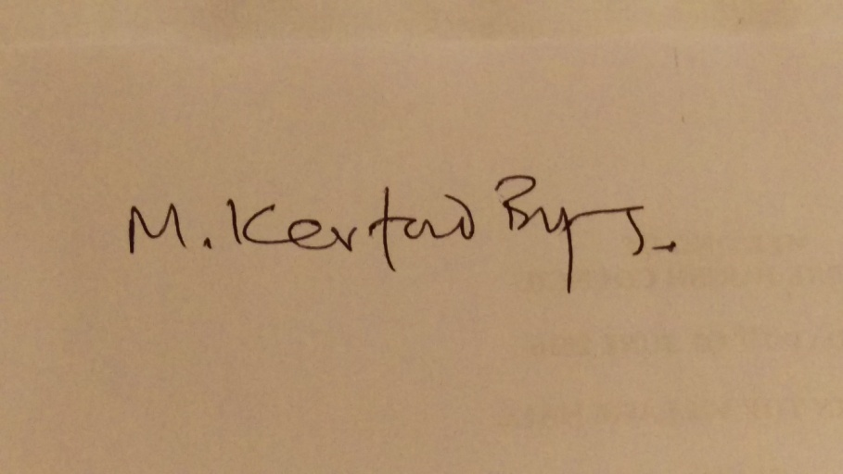
The date of the next meeting is to be May 26th 2020, proposed MKB, seconded ST, carried unanimously. - Meeting closed at 21.20.
CORRESPONDENCE CIRCULATED – None

