REPORTS FOR THE APM 2020
(These reports would have been delivered at the APM in May if it had taken place, the PC felt it would be helpful to post them online)

Chairman’s Report – to follow
Financial Report
County Councillor – to follow
District Councillor
Village Organisations:-
Church
School
Village Hall and Playing Fields Committee
Poors Plot
Operation Playground
Dog Scent Training
Red Lion

FINMERE PARISH COUNCIL RFO’S REPORT 2019 – 2020
We have not administered any large grants this year, so the accounts have remained at a normal turnover level.
Income:
The precept was kept at £11,330 for the year.
The VAT refund returned to average size this year.
Bank interest was slightly higher, but still only a few pounds.
The annual grass cutting payment from OCC remained the same.
The Sports Club were unable to make their annual loan repayment due to the current crisis as they were unable to get cheques signed by more than one person, the amount outstanding is still £800. The Sports Club will make two payments in the coming year to bring things up to date.
The PC did not receive any miscellaneous or anonymous donations this year.
There was the same contribution to grass cutting costs from the Sports Club, which is shared with the VHMC, as last year
There was a new income this year, the Salvation Army clothing bin placed in the village gives monies to the District Council which the PC is entitled to request. This will be an ongoing payment though the amount will depend on contributions to the clothing bin.
The PC received a grant this year from County Councillor Ian Corkin’s fund to replace a bench, this has been spent on a new bench which will be installed when the current restrictions on social distancing allow for a working party.
The VHPFC or Village Hall Management Committee contributed toward mower costs.
Outgoings:
Running costs were a lot higher than last year, rising by some £1,300. Again, electricity prices rose slightly as did the cost of dog bin emptying. The main cause of the rise was an extensive program of fence repair and replacement along with the mower service costs.
Administration was a lot lower this year. This was partly due to some subscriptions, normally renewed in March, not being requested due to a backlog of work in many organisations caused by the crisis. The main reduction though was due to the lack of election costs this year and the PC being able to take an exemption from the full external audit due to low turnover. This meant that despite training costs, investment in administration materials and a rise in cost for the internal audit the overall figure was some £400 lower.
Salary costs increased slightly, there was a 1% increase in salary this year as agreed nationally.
S137 expenditure was very low this year with no requests made to the PC from residents of the parish.
S144 expenditure this year was up from last year as the PC repaired the Cross Tree signpost to help visitors.
S145 - The memorial wreath was again purchased using the S145 power this year.
S26-29 - This power refers to provision of transport and the PC undertook to make a contribution to subsidise the Comet bus service, Finmere being the highest user of this new route.
Grant expenditure There was a grant from the OCC Councillors Community Fund to replace a bench, most of this grant has been spent on the bench, the remainder to be spent on fixing the bench in place when social distancing rules permit.
Capital expenditure was extremely low this year, with only the purchase of some new Christmas lights.
The income over expenditure balance for the year is some £2,990. This is due to the very low expenditure on S137, combined with reduced costs of administration.
The PC has agreed to put £1,500 per year, from the 2019/20 financial year onwards into a set aside amount for the eventual replacement of the mower.
This means that the PC has built up reserves in addition to this of one year’s precept and is now compliant with recommended reserves.
The PC’s total fixed assets have increased by some £500 this year, due to the purchases detailed above.
The precept for the 2019/20 financial year was kept at £11,330, the possible financial repercussions of the current crisis may mean that there will be need of an adjustment next year, particularly with regard to possible inflation rates but the PC will do its best to mitigate these effects.
This is perhaps a good time to remind everyone that the monthly financial report, given at the PC meeting and detailed in the minutes, is available to view online, following transparency changes the draft minutes are now published within a month of the meeting on the website and during the current crisis copies can be obtained from the Clerk, details on notice boards, as it would not be safe for communal copies to be placed in the notice board folder. Anyone wishing to apply for S137 monies can contact the Clerk or approach any of the Councillors who can explain the criteria for eligibility.

REPORT FROM DISTRICT COUNCILLOR BARRY WOOD
Finmere Residents will not be surprised to hear that the District Council has been very busy as have all of local government with the current emergency. As the Business Rates collection authority there has been a huge workload connected to Rates Relief and distributing grants to affected businesses. To date we have distributed some £24m of central government grant to 1800 businesses. There is now a second scheme to administer as well. We are glad to do this as it essential for our local economy but do not underestimate the additional work. This is public money after all and safeguards against potential fraud have to be considered. The staff at CDC have been working beyond the norm and are a credit to the Council.

The second tasking has been in facilitating a huge requirement for volunteer help to the charities that have worked so well in looking after the shielded and the isolated residents. This too has been a great success and the challenge now is to build on the community spirit so well demonstrated by volunteering.

Meanwhile the bulk of Council Officers have been home working and this too has gone much better that I thought. It will change, I think, working practices well past this current crisis. Not all staff can work from home and I pay particular thanks to our waste collection operatives. A seamless and excellent service.

Finmere PC know they can contact me at any time (not literally but you know what I mean).

St Michael and All Angels, Finmere
June 2019 – May 2020
What a year! Last year we recognised with sadness that without considerable support from the local community there was a real possibility that the church might have to look to closure. The regular churchgoers were older and less able, and the financial situation of the church was dire. But the village has come up trumps, and although there is much work to be done, things seem more positive.
Community Support
Although our regular congregation continues to be small, and we still have no church wardens and a PCC of only four, we have been very grateful for the input from the ‘Finmere Friends’.
- Jo Brooks, and Tracy and Glyn Jones have regularly attended PCC meetings, been key in organising various events, and have brought fresh ideas and energy.
- various folk came to ‘Pimms in the Parish’ in Tilehurst Farm garden in the summer to hear about the financial situation, and quite a few people have signed up to the Parish Giving Scheme.
- Jacky Horwood and friends organised a fabulous village fete in August
- Graham Hawkins took on a motley crew of dancers for ‘Strictly comes to Finmere’ and we all thoroughly enjoyed it
- lots of you came to the ‘cheese and wine’ event in November to see the exciting drawings by Paul Webber, showing the possibility of fitting a toilet and servery area into the back of the church
- the proceeds from the annual village carol singing were kindly donated to the church
- David Green offered to clean the church windows – with amazing results
- we enjoyed a fantastic Burns supper in January
Unfortunately, the plans we had for 2020 have all been put on hold due to Covid. We were looking forward to putting up the newly restored WW1 grave marker as part of the VE day celebrations, but as it was, we had to be content with ringing the bells (rather badly, it has to be said, but only the rector and husband were allowed in the church at that time.)
Covid-19
Sadly, during the pandemic the church building had to be closed and most of our regular activities ground to a halt.
However the church continued to be active. We have live streamed services onto Facebook, held weekly social events on Zoom that have supported a number of folk otherwise by themselves, and contributed to the village support network.
We are looking forward to being able to reopen the building for private prayer and quiet reflection from Sunday 21st June, but it will be a little while yet until services are happening again in the church.

How you can help us
We still need your support. We would love to make the church into a more useful space for the village but to do that we need money and people power. Perhaps you could:
- sign up to the ‘Parish Giving Scheme’
- offer to help with grant applications / fund raising / form filling and enable us to get a loo and servery in the church
- offer to become a ‘Finmere friend’, join the PCC, be a church warden!

For any further information, do get in touch.
Alice Goodall
Rector
01280 848192
alicegoodall313@gmail.com

Headteacher’s Report for Finmere Parish Council
June 2020

Thank you for inviting me to submit a report for the Parish Council records.

Whilst the past few months have seen challenging times for us all as a community, it is pleasing to pause and reflect on the developments and good work that had been taking place in our school before the sudden closure, on 20th March 2020, due to the Covid-19 pandemic. This report also gives me the opportunity to share with the community, how positively our wider school ‘family’ has responded during the recent difficulties and how we have continued to support our pupils and their families.

We enjoyed a very positive start to the year with a large group of new Foundation Stage pupils joining the school. Ten excited four-year olds joined Willow Class, increasing our whole school number to 51. As some of you may remember, increasing pupil numbers has been a real focus for us over the past few years and we were delighted to welcome such a strong intake for the new academic year.

Increased pupil numbers have enabled us to initiate three full-time classes and further improve the teaching and learning at Finmere. Our three classes are; Willow for EYFS/Year 1, Maple for Years 2 and 3 and Redwood for Years 4, 5 and 6. It has been wonderful to see all three classes full and busy with pupils engaging in an exciting curriculum whilst still enjoying the benefits of small-class sizes.

Early in the new term in September 2019, we undertook a very successful residential trip to Culmington Manor in Ludlow, Shropshire. 20 pupils from KS2 were accompanied by 4 members of staff on a week-long outdoor adventure trip taking part in activities such as canoeing, climbing, abseiling, hiking, den-building and archery. For many pupils, this was the first time away from home and although this can bring its own challenges across a week away, a great time was had by everyone.

It was a pleasure to spend an exciting and memorable week with such a strong group of children who demonstrated resilience, determination and a sense of humour in everything they tackled. Every pupil returned home with a real sense of achievement and increased self-confidence and we thank all the parents involved, for enabling their child to experience such a valuable event.

We have continued to work in close partnership with Revd. Alice Goodall, Shelswell Benefice and the wider diocese. The children really enjoy attending church and taking part in our festival services at Harvest, Remembrance and Christmas. Our preparations for the Easter service were well under way when school closed suddenly. We have hosted several successful Messy Church sessions with parents and the wider community and had just began to host Funday Club sessions with Jen Iddon; we look forward to resuming these sessions again from September.

In November the whole school participated in a Festival of Light Prayer Week celebrating the importance of light across three key festivals from three different faiths. The children learnt of stories and the deeper meanings from the Hindu festival of Diwali, the Jewish festival of Hanukah and the Christian festival of Advent. By comparing and contrasting the faiths the children were able to see how light is so important to believers and is a key theme, signifying truth over darkness and hope over adversity.

December is always busy at school and this year was no exception. We all enjoyed our now annual trip to the Pantomime in Chipping Norton theatre and taking part in the church Carol concert. A particular highlight for the children, this year, was being able to switch on the Christmas Lights. In addition, we were visited by Father Christmas, and our PTA, Friends of Finmere School Association (FOFSA), hosted an extremely successful Christmas Fayre raising vital funds for us.

FOFSA had committed their fund-raising efforts last year to purchasing and installing a new timber-trail playground for all our pupils to enjoy. We excitedly watched this being installed in the final few weeks of July and all the children immediately began to have fun on this. It has been particularly poignant to see this wonderful new facility stood empty over the past few months.

As always, we are extremely grateful to FOFSA and the wider community for supporting our fund-raising events so passionately. Again, it was disappointing not to be able to host the popular Spring Fete in May and the impact of the missed fund-raising opportunity will be felt by the school. However, the FOFSA team remain committed and are already turning their attention to activities and events in the near future.

One key change for the school this year, was our conversion to academy status by joining The Warriner Multi-Academy Trust. Whilst externally there is very little change to see, behind the scenes there have already been many changes. We now have the benefit of being part of a wider group and are supported closely by a central services team who can provide much needed guidance and advice relating to all matters concerning premises, site maintenance, health & safety, personnel and finance. Most importantly though, our decision to join this trust was its commitment to maintaining the ethos and viability of a small, village school and the support it was able to offer to improve teaching and learning outcomes for our pupils.

In the short time since conversion, on 1st March 2020, the central service team have proved invaluable help during this extremely difficult time and the wider support of partnership staff have really guided practice for teaching staff. We are excited about further developing our relationship within The Warriner Multi-Academy Trust and look forward to the benefits this will bring for all our pupils.

As a final note, I’d like to express my sincere thanks to all our parents, families and the wider Finmere community. Like all schools, we were thrown into a situation we had little time to prepare for in March. Throughout the period of lockdown and school closure we worked hard to keep in touch with all our families and provide home-learning tasks that were both meaningful and manageable for parents. The responses we received from parents and wider partners has been so overwhelming positive and supportive; often including messages of love to staff and thanking us for our efforts and these responses have meant such a great deal to us all. We have missed the children terribly but the positivity and enthusiasm from pupils and parents in embracing the sudden change and being so willing to adapt so quickly, has meant our whole school community has been able to stay safe and well.

Our school motto is 'Challenging all to Shine' and is underpinned by the parable of the light under a bushel: 'You are the light of the world...let your light shine before others, that they may see your good deeds and glorify your Father in heaven' Matthew 5: 14-16. On a daily basis, we challenge our pupils to shine, even when they find things hard. We ask ourselves; how can my light and my strength help others? We have experienced many occasions over the past few months where we have felt so much pride in our pupils who have demonstrated their strength, their resilience and their light and this has been a true blessing for us during this very difficult time.

As I have mentioned in previous years, many of our events are recorded in photographs and are on display on both our school website and school Facebook page. I encourage you to take a look at some of the exciting things we have been doing.

Thank you to all our partners for your on-going support.

Caroline Tucker
Headteacher
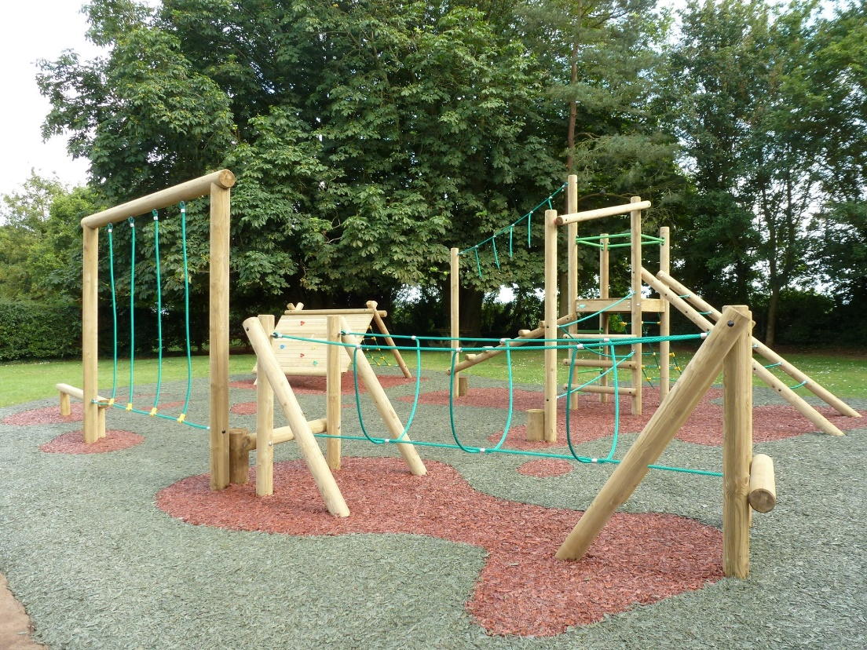
29th May 2020

Village Hall and Playing Field Committee Report

The hall continues to be available for hire by personal health and wellbeing classes,
children’s play sessions, a variety of clubs and equally available for hire by local and
district residents.

Due the challenging times we have closed the hall to all users since March 2020.
During 2019 and up to March 2020 our regular users were dog training clubs, fitness
classes, playgroups, the local school tuckshop, dance classes and the Parish Council. As in the past, it has also been used as a polling station and hosted a number of social events.

The village hall and playing fields require continuous maintenance and replenishment of equipment, to meet the basic needs and increased expectations of hall and playing field users. Alan Jones has been unwell for some time and some of the tasks that Alan did are now maintained by Trevor. The trustee's thanks go to Alan and especially to Trevor Jones who spend many hours throughout the year looking after the playing field.

Funding strategy and reserves policy

The hall management strategy is to maintain the revenue budget on a self-financing
basis i.e. lettings and hires. Currently the hall has sufficient reserves for day to day
expenses and it is our aim to maintain that status. The hall is also building a reserve
fund for future capital projects.

There were no major expenses incurred during the year and all expenses related to
ongoing management of utilities and maintenance. The hall management and Parish
Council continue to seek a formal lease agreement with Finmere Sports Club for the
use of the pavilion. An agreement has been reached with the Sports Club for the
recovery of some of the funds invested in grass cutting equipment, and the creation of replacement funds to provide for both regular maintenance costs and the re-building of reserves related to the field maintenance.

Volunteer contributions, grants and fundraising

The new ‘grant procurement’ sub-committee continued to seek means by which grants may be obtained in relation to planned improvements in hall facilities. The committee continued discussions relating to possible grants from the HS2 representatives, Groundwork UK.

In December, after a long and time-consuming process, Emily Ackland safely secured a grant of £75,000 under the HS2 Community and Business Funds. A huge thanks to Emily for her hard work and time for securing the grant. The funds are to provide a new roof, an extension to the north side of the hall which will create additional storage, and a garage for the lawn mower. French doors will also be installed to the rear of the hall and these will open up onto the picnic area, with a paved terrace also to be added.

The Village Hall Management Committee continues to operate under an informal
authority from the Parish Council. The committee believes that this arrangement
represents an issue and should be resolved by the Parish Council as soon as possible, by way of a formal agreement/lease.

Operations Playground

Subcommittee to Village Hall and Playground Committee

The sub committee overseas the running of the playground and it’s funding. It has had a relatively quiet year. Thanks to amazing efforts by Lynne Cooley and Friends of Finmere School Association and a few Playground volunteers, the subcommittee has a healthy surplus of funds.

The key issue raised by park users has been that of an increasing amount dog mess on the park . The committee has debated this at length and considered their options but feel even with the measures in place they feel it is lack of supervision by owners.

Future plan for the playground is expand the number of items in the park to make it a
desirable area for local children.

Future plans

The core activity of the hall and playing fields management is the delivery of a
sustainable, safe and high quality community building for the use and benefit of the
village. This is in line with our charitable objectives. We have been in a steady, sound and well established financial state throughout the past year and will continue to manage and run the hall, ensuring that we can meet the following priorities:

• The hall is properly and fully maintained.
• Running costs continue to be met.
• Build up reserves to cover future repairs and capital projects.
• Continue to have a strong and dedicated management committee that
continuously reviews, updates and improves our management process.
• Monitor and react to the needs of users and the wider community.
• Promoting the hall for use by the local community.

Finmere POOR’S PLOT
Annual Report 2019/20
The members of the Poor’s plot management comprise of Anita Bilbo (secretary), Paul Nash (chairman), Phillip Rushforth (treasurer), Sandy Tresise and Alan Cochrane.
Background
The Finmere Poor’s plot comprises of a plot of land of 12 acres located to the west of the village. The land was originally made available for the use by the ‘poor of the village’ on a date prior to 1667. Without going into the ‘trials and tribulations’ of the management of the plot over the intervening years, the plot has never proved to be really suitable for the growing of vegetables, as was originally intended and is currently rented by Peter Lepper for the ‘growing’ of sheep. For those interested, there is an excellent history of the ‘poor’s plot’ written by Anita Bilbo, available on the website www.myfinmere.com/poorsplot In addition, Peter Lepper, some years back, was good enough to make available a section of a field adjacent to the village hall, sub-divided into 24 allotment plots. The plots are managed by Anita, as secretary of the poor’s plot.
Poor’s plot Income
Income therefore comprises of the rent paid by Peter Lepper for the use of the original field plus allotment plot subscriptions. The Poor’s Plot constitution states that income is used for ‘….. the sole benefit of the residents or ‘needy’ of the village of Finmere’
Expenditure
The Poor’s Plot incurs an annual cost relating to public liability insurance, otherwise there are no regular operating costs. In the last year, the poor’s Plot agreed to grant the Finmere Parish Council a sum of £1,000 towards the cost of the acquisition of the spinney that is attached to the village playing fields. This sum is currently held by the Poor’s Plot, awaiting Page 2 of 2 confirmation by the PC that an agreement has been reached with the Mixbury Trust, the owners of the spinney.
Outlook
The recent lockdown restrictions related to COVID 19 have resulted in an increase in demand for allotment plots and the allotment area has undergone an upsurge in activity. Whilst not necessarily resulting in increased income for year 2020, it is hoped that new allotment holders will further contribute towards Poor’s Plot income in the coming years. Only 2 allotments are now currently vacant and any local resident who is interested in taking an allotment should please register their interest with the Secretary, Anita Bilbo who no doubt will advise them on the joys of allotment holding. Alternatively visit the website www.myfinmere.com/poorsplot
The committee continue to discuss options for the further application of Poor’s Plot funds, and especially in the period of COVID 19 lockdown, welcome any viable suggestions that Finmere residents may wish to make in this regard.
Paul Nash
Chairman May
2020

Operation Playground Update June 2020

This has been a relatively quiet year for Operation Playground but our funds have been steadily increasing thanks to the amazing efforts of Lynne Cooley and the Friends of Finmere School Association (and a few Operation Playground volunteers)
who have helped run the Tuck Shop. We currently have £1365.14 in surplus funds despite providing finance to share the cost of a new access gate to the green with the Village Hall and Playing Fields Management Committee

A key issue raised by park users has been that of an increasing amount of dog mess on the park. The committee have debated this at length and do not feel that expensive solutions like a fence or CCTV are currently appropriate. The committee feels that a fence incorporating the play area would spoil the views of the park and the playing fields especially once the new hall extension is complete. There is also no guarantee that it would keep dogs out. A lack of supervision of dogs is one of the issues leading to the dog mess and so a post and rail type fence may not keep these kinds of dogs out. A more substantial fence would be cost prohibitive.

For now the committee feels that a more active anti-dog mess campaign is most appropriate and more signs have been put up in the playing fields asking people to clean up after their dogs. These were also shared on social media. The issue will continue to be monitored.

In the long term the committee would like to expand the number of items in the park to continue to make it a desirable area for local children. We would also like to thank the Village Hall and Playing Field Management Committee particularly Alan and Trevor for their work on monitoring the condition of the park and maintaining the area beautifully.

We look forward to children to be allowed on the park again, once the spread of COVID 19 has been stopped.

Tracking Lines Dog Scent Training

My classes and running the trials from Finmere Village Hall continued to grow until unfortunately everything came to a crashing halt because of covid 19. We are now in week 9 of ‘Lock Down’ and I fear this is likely to continue until the Autumn when maybe I might be able to resume activities once again. Unfortunately, I don’t know what sort of impact this will have on my classes & trials, but I suspect that it will. It is unfortunate that I cannot be more optimistic about the future and I know that I am one of many in the same situation. However, before the lock-down, a big thank you to Phillip Rushforth for putting up with my numerous e-mails even responding whilst he was on holiday whenever I wanted to book the hall. Alan who cleaned the village hall spotlessly every Monday until his unfortunate accident last year and also to Paul Nash & Steve Trice for sorting out village hall repairs so efficiently.

The Red Lion
All be it briefly

A challenging year to say the least but with a huge support from the community we have managed to keep
Going !
Looking forward to reopening and serving drinks in glasses again !!

