REPORTS FOR THE APM 2021
(These reports would have been delivered at the APM in May if it had taken place, the PC felt it would be helpful to post them online)

Chairman’s Report – to follow
Financial Report
County Councillor’s Report
District Councillor’s Report – to follow
National Paralympic Heritage Trust
Village Organisations:-
Church – to follow
School
FOFSA
Village Hall and Playing Fields Committee – to follow
Poors Plot
Operation Playground
Dog Scent Training – Tracking Lines
Red Lion
Sports Club – to follow

FINMERE PARISH COUNCIL RFO’S REPORT 2020 – 2021
We have administered a grant for the village hall roof this year, so the turnover is higher than usual.
Income:
The precept was kept at £11,330 for the year.
The VAT refund is much larger this year due to the expenditure of the grant.
Bank interest was slightly lower, only a few pounds.
The annual grass cutting payment from OCC remained the same.
The Sports Club were able to make one payment on the loan, that which was carried over from last year, but did not make this year’s payment or their contribution to the grass cutting as the club was unable to function due to Covid 19 restrictions and the PC agreed to waive these payments for the year.
There was no income from the Salvation Army clothing bin this year as it had to be taped up due to Covid.
The PC received a grant this year from HS2 for the village hall roof.
There was a small amount of income raised by the sale of the ‘ride-on’ animals which were removed from the Stable Close play area.
Outgoings:
Running costs were a lot higher than last year, rising by almost £2,500. This was largely due to the payment of VAT on the grant expenditure. There were no costs of fence repair or ink this year and the village hall and mower maintenance was less, but defibrillator costs were up, as were the cost of subscriptions and the cost of grass cutting, due to additional cuts being needed as there was a heavy growing season.
Administration was a little higher this year. There was less expenditure on training and no manual to buy but there was a land registry fee, as the PC had to prove ownership by HS2 of a house in the village, and the inclusion in admin, rather than running costs, of one of the PC subscriptions. The main reason for the difference was expenditure on the new logo design, for both the website and for correspondence purposes.
Salary costs increased slightly, there was a 1% increase in salary this year as agreed nationally.
S137 expenditure was again very low this year with no requests made to the PC from residents of the parish.
S144 expenditure this year was zero.
S145 - The memorial wreath was again purchased using the S145 power this year.
S26-29 - This power refers to provision of transport and this was zero as the Comet bus service was suspended due to Covid 19.
Grant expenditure There was a large grant from HS2 for the roofing of the village hall.
Capital expenditure was a little higher this year, with the purchase of a new cabinet for the defibrillator.
The income over expenditure balance for the year is some £3,145. This is mostly due to the very low expenditure on S137, combined with the lack of expected legal costs that had been budgeted for.
The PC has agreed to put £1,500 per year, from the 2019/20 financial year onwards into a set aside amount for the eventual replacement of the mower. The set aside amount is now £3,000.
This means that the PC has built up reserves in addition to this of one year’s precept and is now compliant with recommended reserves.
The PC’s total fixed assets have increased by some £250 this year, due to the purchase detailed above.
The precept for the 2021/22 financial year was kept at £11,330, again the possible financial repercussions of the current crisis may mean that there will be need of an adjustment next year, particularly with regard to possible inflation rates but the PC will do its best to mitigate these effects.
This is perhaps a good time to remind everyone that the monthly financial report, given at the PC meeting and detailed in the minutes, is available to view online, following transparency changes the draft minutes are now published within a month of the meeting on the website and during the current crisis copies can be obtained from the Clerk, details on notice boards, as it would not be safe for communal copies to be placed in the notice board folder. Anyone wishing to apply for S137 monies can contact the Clerk or approach any of the Councillors who can explain the criteria for eligibility.

2021 Annual Report
Prepared by Cllr Ian Corkin
With so many elections taking place on May 6th (including my own County seat) I may not be able to make you annual parish meeting and I thought a written report would be helpful.

2020/21 has been dominated by the Coronavirus pandemic. It has arguably been the biggest civil emergency since World War 2 and certainly the most serious public health emergency in over 100 years. Councils have been at the forefront of the response, being called on to deliver a whole range of support services, often with no precedence and with a workforce of over 5000 people working from home. Partnership working has been more important than ever and Oxfordshire County Council has worked closely with the city and district councils, NHS and various voluntary organisations and charities to support residents and businesses in the County. I am happy to say that in addition to C19 related activities, the councils “business as usual” activities have also continued, albeit sometimes in different
ways. Highlights of both include:
• Adult Social Care:
Experienced a 30% increase in demand
Delivered 25% more homecare visits
Commissioned over 100 mental health assessments each month

• Children Services, Education & Families
Continue to look after more than 770 children in care
Successfully supported schools and families and achieved a 97.3% return of
pupils in March
Implemented a full test regime for every pupil in Oxfordshire
Followed up, on average, 438 contacts per week from the Multi Agency
Safeguarding Team (MASH)

• Customer Services:
Handled over 90,000 calls and 40,000 emails
Maintained or improved all key performance indicators
Made over 10,000 outward bound calls and 6700 emails to clinically very
vulnerable residents who were asked to shield.
Contact tracing team successfully contacted over 2000 people that the
national test and trace had not been able to reach

• Financial Support
Paid out £2.3million pounds in grants for food and other essential items to
community food services and those in need
Supported children in receipt of free school meals with £15 per week during
the Christmas, February and Easter holidays

• Highways
Took the opportunity of quieter roads to treat 1.5million sq.M of highways at
over 220 sites
Repaired over 40,000 potholes

• Countryside Team:
Repaired 87 foot & bridle bridges
Cleared 1765 miles of public rights of way

• Fire & Rescue
Were often at the forefront of the C19 response
Carried out 2334 Safe & Well visits
Fitted 1214 smoke alarms for vulnerable residents
Delivered 800 laptops to more than 140 schools to support home learning

• Trading Standards
Investigated over 600 C19 related complaints
Recovered £49,000 for victims of scams and doorstep crimes
Blocked 26,000 nuisance and scam calls

• Cultural Services (including libraries)
Delivered 12,000 online music lessons to schools
Loaned 926,335 items to readers, including more than 24,000 items during
the first two weeks of the click and collect services

• Registrars
Maintained death registration service throughout the pandemic
Cleared a backlog of 7193 baby registrations in just 7 weeks once they were
able to do so again in June
Carried out 1052 citizenship ceremonies

There are very many more examples of the extraordinary range of activities, but I hope this gives a taste of the highlights. Of course, this has all come at a cost. The national government have supported the majority of this activity financially, but there is still a shortfall and whilst work continues to close that gap, it will continue to wash through the accounts of both OCC and CDC for some time to come.

Turning to my own ward/division, it was incredible to see how the community responded to the pandemic. Across the county and in every parish I represent, community volunteers came together to support vulnerable friends and neighbours. This was enormously helpful to CDC/OCC who could literally call on help on a street by street, village by village basis. Harnessing that goodwill and ensuring we deliver a strong recovery from C19 will be an important priority for me going forward.

Of course, there are challenges too:

The adverse weather events in November and December 2020 resulted in
considerable internal property flooding across more than 12 parishes. I instigated
more than 12 flood investigations and I am currently working closely with OCC, CDC,
Thames Water and the Environment Agency to ensure we do as much as possible to
minimise the impact of more intense weather events in the future. I am happy to
say that work is making good progress, with real change already happening on the
ground in many of those affected areas.

Speeding remains a problem in many villages. I have worked with communities to
ensure that where there is a desire to do so, they can engage with the correct OCC ​
officers to implement 20mph schemes. This has already happened in Mixbury,
Wendlebury & Launton (school zone) and soon, Heyford Park and Chesterton.
Likewise, I have used my Councillor Priority Fund to help implement additional traffic
calming measure, such as the Vehicle Activated Signs in Lower Heyford, Fringford &
Stratton Audley. Mitigating the impact of traffic, particularly HGV traffic, will remain
a priority in the year to come.

The area remains under considerable pressure from inappropriate & speculative
development, as ever, I stand ready to oppose that wherever it happens and I have
led a number of refusals for such schemes at CDC planning committee. Equally, I
remain committed to ensuring that communities are fully represented with bodies
such as HS2, East West Rail and Dorchester.

As you will see from the attached report, over the past 3 years I have used my
Councillor Priority Fund and other Covid related grants, to support a full range of
village priorities. Grants in my division over that period have totalled more than
£47,000, which often helped free up other contributions, meaning that the
community I represent has benefitted by more than £100,000 of funding to support
their local priorities.

I have also worked closely with a number of local businesses and organisations who
did not automatically qualify for government support grants, successfully securing
more than £100,000 of grants that they would not otherwise have received.

There is also a whole range of casework that I engage in on behalf of individual
residents. By its nature, it is often very sensitive and it would be inappropriate to
discuss it, but it remains some of the most challenging and rewarding work I do in
the division

I hope that gives a flavour of the work that has been carried out over the past 12 months. I’d like to say that I had been able to achieve everything I set out to do, but sadly some remains a work in progress, but I look forward to working with renewed vigour post-election, to help ensure that we really do build back better and stronger, enabling our communities and their very many voluntary organisations, to hit the ground running as we emerge from lockdown.

Finally, I would like to thank all of the community volunteers and members of the parish council, who freely give of their time to help make the places we live special. You really are the best of us. Thank you for all you do!
Best regards
Ian

Councillor Priority Fund & CDC Covid Response Funding Awards over the 2018/19, 2019/20, 2020/21
• Ardley with Fewcott
o
Village Hall & Playing Field Management Committee New boiler replacement:
£1,500.00
o
AwF Gardening Club support for annual produce show: £420
o
Village Hall & Playing Field: Vehicle entry barrier & Marquee: £686
o
Village Hall: Heating/cooling unit for meeting room: £1195
Sub-total: £3801
• Blackthorn
o
Village Hall: Community microwave: £250
Sub-total: £250
• Chesterton
o
Help with additional allotment costs during Covid: £500.00
o
New printer for weekly community C19 newsletter: £494
o
Chesterton Football Club: C19 safety packs for all teams: £500
Sub-total: 1494
• Finmere
o
Replacement village bench: £500
Sub-total: £500
• Fringford
o
Shelswell & Fringford Preschool: All weather play area: £1000
o
Life Education Wessex & Thames Valley Life Bus visit to school: £550
Sub-total: £1550
• Hethe
o
Parish Council: Bench & Lawnmower for park £800
Sub-total: £800.00
• Heyford Park
o
Residents & Community Development Association Event Tent £720.00
o
Residents & Community Dev Ass. Equipment to support pandemic food
parcel distribution to shielding residents: £447
o
Heyford and Bicester Veterans Group
Community Centre kitchen equipment £769.95
o
Heyford & Bicester Veterans Group: Phone & Internet contact and general
support for activities: £ 1280
o
Support for Heyford Park Pantry (food bank): £500.00
o
1st Heyford Park Scout Group
COVID 19 re-start programme: £1,000.00
o
Heyford Park Football Club: COVID safety
support: £335.00
o
Heyford Aardvarks Running Club: Club development funding: £700.00
o
Community Garden: New secure shed: £500
Sub-total: £6252
• Launton
o
Village Rock Chorus: post COVID recovery support: £335.00
o
Launton Lines Newsletter: Post Covid recovery support: £335.00
o
Friends of Launton School: community outreach equipment: £1290
o
School 20mph zone: £2000
Sub-total: £3960
• Lower Heyford
o
Bowls Club: New roof for outside area: £648.00
o
Bowls Club: Replace fence and new equipment shed £1440
o
Replacement gates on playing field: £2,000.00
o
Kings George Playing Field: Pavilion refurbishment: £2000
o
Parish Council: Village wide speeding signs scheme £4650
Sub-total: £10,738
• Middleton Stoney
o
Village Improvements
& planters: £1,000.00
o
Middleton Stoney Cricket Club
post COVID recovery support: £335.00
Sub-total: £1335
• Shelswell Benefice
o
Little Lambs Parent & Toddler Group: Safety equipment & Minibus hire for
Shelswell by the Sea outing: £1263
o
Shelswell History Festival: Financial support: £500
Sub-total: £1763
• Stoke Lyne
o
St Peters PCC: New kitchen as part of refurb: £2637
o
St Peters PCC: Provision of broadband to community space: £414
Sub-total: £3051
• Stratton Audley
o
Repair of village clock £1,800.00
o
New footpath around village pond: £1500
​o
Vehicle activated speed sign: £1800
Sub-total: £5100
• Upper Heyford
o
Support for the village Reading Room: £500.00
o
Planting trees and hedgerows: £1,000.00
Sub-total: £1500
• Division Wide
o
Start-up-online: COVID-19 Peer Mentoring scheme £1000.00
o
1st Fritwell Scout Group: Refurbishment of premises to make Covid
compliant: £250.00
o
Oxford Care Leavers Association: Christmas presents for care leavers
£200.00
o
Children in care Christmas dinner £131
o
Children in care Christmas event £500
o
Comet Community Bus: £2885
Sub-total: £4966
Total Grants 1
st
April 2018-March 31st 2021: £47,060

The “Stories from Finmere “ Project

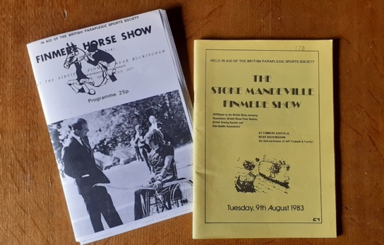

Programmes from the Finmere Show.
Courtesy of Anita Bilbo.

Hello and thank you for inviting me to tell you about an exciting project that we are planning at the
National Paralympic Heritage Trust called “Stories from Finmere”. It is a project which will provide a
unique opportunity to connect our British Paralympic heritage with the community of Finmere, who
supported the Paralympic Games from the very beginning.

Who we are:
The National Paralympic Heritage Trust was established in July 2015 to protect and share British
Paralympic heritage. Based at Stoke Mandeville Stadium in Aylesbury, the team look after a wide
range of fantastic photographs, letters, sports equipment, documents, medals and Paralympic
clothing which tell the story of the Paralympic Games and its origins in Buckinghamshire.
The Paralympic Games is an international sports festival for disabled athletes, held every four years
immediately after the Olympic Games. It is one of the world’s largest sporting events held every four
years.

The Games forms part of a wider Paralympic Movement that changes lives through the promotion of
sport providing a means of improving both physical health, confidence and self-esteem amongst
disabled people. This important piece of British heritage highlights how disabled people can live
healthy fulfilled lives as active members of society. We at the Trust firmly believe that by learning
from history we can challenge negative perceptions and actively encourage inclusion for disabled
people across all areas of life.

The Paralympic Movement is a story with unique British involvement. Displays at the Heritage Centre
at Stoke Mandeville Stadium and at the National Spinal Unit at the Stoke Mandeville Hospital map this
remarkable journey. A journey that began in 1943, when neurologist, Professor Sir Ludwig Guttmann,
a German Jewish refugee, came to Stoke Mandeville at the invitation of the British Government, to
set up a spinal centre in preparation for the D-Day landings. Here he revolutionised the treatment of
spinal injuries patients by including physiotherapy and, crucially, sport to the rehabilitation programme.

Professor Guttmann was pioneering in his vision, but his vision could not have been fully realised
without the involvement of many local people working behind the scenes across this region. Ordinary
people, working at the hospital and in local communities like Finmere. In recognition of this historic
community effort, the Trust are inviting the Finmere community to tell its story, a story that spans
more than 30 years and one which played a significant role in bringing the world the Paralympic
Games.

The Finmere Horse Show and Sally Haynes
In 1959 the first Finmere Show was held at Hill Leys, Finmere, to fundraise for steeplechase rider, Sally Haynes. At 19 years of age, Sally sustained a spinal injury due to a horse-riding accident at a point-to-point meet. Sally needed assistance with funding as she did not have insurance on the horse she had been racing. The show was organised by her friends and family, many of whom were from the riding communities of Buckinghamshire and Oxfordshire.

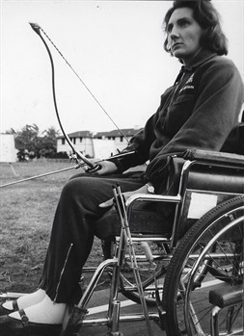

Sally Haynes at the 1964 Tokyo Games
.
Image © Sally Haynes/NPHT

The first Finmere show included top class steeple chasers and show jumpers. Amongst them were
Lester Piggott, David Broome, Gerry Scott, Eph Smith, Fred Winter, Harry Carr, Dave Dick, Bryan
Marshall, Michael Scudamore, Alan Oliver, Wilf White, Sue Cohen and Dick Francis. It was one of the
largest one-day horse shows held in the country that year, attracting over 6000 spectators.

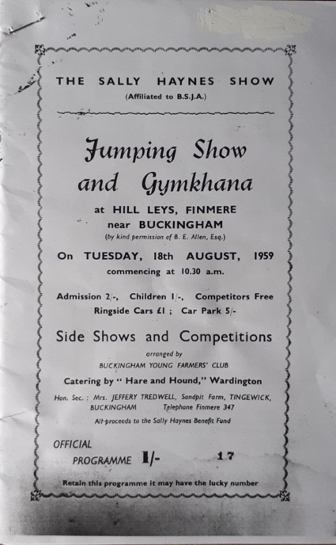

Programme of The Sally Haynes Show 1959.
Image © Sally Haynes/NPHT

After that first show in 1959, Sally asked if the money raised in subsequent shows could go to the
Paraplegic Sports Fund at Stoke Mandeville Hospital, due to the great care she had received there. The huge success of that first show led to the Finmere Show becoming an annual event which ran
until 2015. Prince Philip became the Patron of the show.

In 1960, Sally organised the show to raise the air fare to transport around 50 wheelchair athletes to
the Games in Rome that year. This show included an archery demonstration from patients at Stoke
Mandeville hospital. Other displays included a show jumping event, Gymkhana and Donkey Derby.
The British team won 21 gold, 15 silver and 18 bronze medals at the 1960 Rome Games.

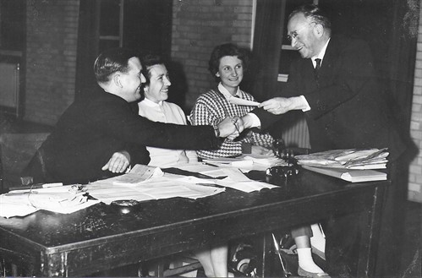

The Finmere horse show committee, presenting Dr Guttmann with a cheque for £3097 18s after the 1960 Finmere Show.

Left to right: Lionel Vick, Chairman, Jane Tredwell, Secretary, and Sally Haynes, Vice-chairman and Assistant Secretary.
Image © Sally Haynes/NPHT

The Donkey Derby provided the most popular entertainment at the show, drawing a large crowd.
Participants were required to have competed in the Grand National or Epsom Derby to race in the
Donkey Derby. This event saw jockeys attempting to control the donkeys, round the course of three
‘jumps’ made of straw bales – no mean feat and most of them were thrown off!

​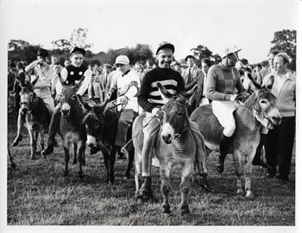

The Donkey Derby at the 1960 Finmere show.
Left to right: Bruce Hobbs, Michael Scudamore, Eph Smith, Dick Francis,
Michael Medwin, Tom Hudson, Dave Dick, Jan Ridd, Ted Edgar.
Image © Sally Haynes/NPHT

The Finmere Show was very much a community effort and involved many local groups and businesses. In total, the shows raised more than £50,000 for the Paraplegic Sports Fund at Stoke Mandeville Hospital.

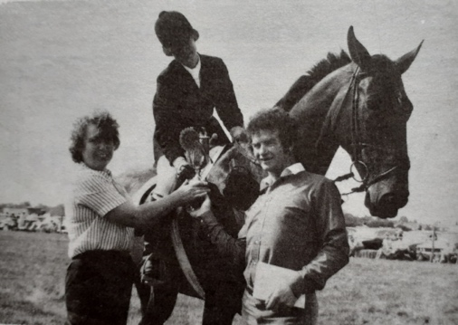
Dina Blackwell (William Hill Organisation) and Vincent Kilkenny (Strada Construction) presenting the Stoke Mandeville Games Show jumping Championship trophy to Amanda McGlynn.
Taken from 1983 programme.
Courtesy of Anita Bilbo

Some of the stories surrounding the show have been collected but there are many more to uncover. Personal stories of involvement, support and enjoyment all make for a broader and better understanding of the impact that the Finmere Show had on the lives of so many. If you have a memory that you would like to share relating to the development of the Paralympic Movement in Buckinghamshire, then please do get in touch. We would really like to hear from you.

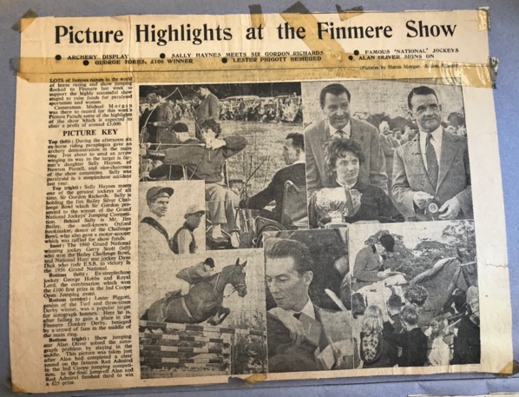

Newspaper clipping of The Finmere Show 1960.
Image © Sally Haynes/NPHT

As partners in this project, the Trust will be inviting you to meet Paralympians who will share their story and talk about what impact being able to compete at the highest level of sport has made on their lives. You will also work with disabled artists and together you will develop creative links with our collection which is rich in medals, costumes, photographs and memorabilia. But central to this project is the coming together of generations to share memories, photographs and stories about the Finmere Show and this incredible community effort that took place here on our doorsteps. Through informal sharing and investigation, we will ensure that Finmere’s contribution to the Paralympic Games is never forgotten.

As the project develops in the school and the community there will be a number of ways that you can get involved, from baking cakes for a community sharing event, to helping exhibit work produced alongside your disabled artists by school children and community groups. You may want to help to create a pop-up museum that can be taken to local events across the region to share the story of the Finmere Show. But you might simply like to come along to support the Meet the Paralympian events and the disabled artist workshops. You will be made very welcome. If you would like to find out more, please do contact me for an informal chat.

Our mission statement at the Trust is simple: “We exist to enlighten and inspire future generations by celebrating, cherishing and bringing the Paralympic heritage and its stories of human endeavour to life”. I hope you will want to be a part of this endeavour and a part of the history of the Paralympic Games as it continues to unfold.

We are very much looking forward to working with you.

Fiona Darling-Glinski
Learning Officer
National Paralympic Heritage Trust

Please email fionadarlingglinski@paralympicheritage.org.uk

Finmere CE Primary School

‘Challenging all to shine’

Headteacher’s Report for Finmere Parish Council
May 2021

Thank you for inviting me to submit a report for the Parish Council records.

We began the year positively. We were delighted to be fully open and to have all our children
back together in school. Whilst we still had to maintain and adhere to a wealth of DfE guidance, we were able to operate in an almost ‘normal’ way and our children were able to experience the joys of being back with their friends and learning with their class teachers.
We maintained our link with Revd Alice and were able to make visits to church for Harvest,
Christmas and for the wonderful outdoor Experience Easter event just recently. During the
difficult times we have all experienced this year, our links with the church and the wider
community have become even more important to us. Revd Alice’s virtual assemblies have been a particularly highlight of the year and have been much appreciated by our pupils, families and staff.

Then in January we were hit, along with everyone else, with Lockdown 3.0. Having been so successful across the autumn term, it was extremely upsetting to have to revert to closing our doors to the majority of pupils again. However, with all the staff on a very steep learning curve, we quickly adapted to yet another new ‘normal’. Throughout the period of Jan - March, we accommodated 8 – 16 children on a daily basis on site, prioritising pupils from vulnerable backgrounds and began the delivery of a programme of remote learning to the rest of our pupils. This time, however, like schools all across the country, under the scrutiny of national media and increased governmental pressures. The period that followed was incredibly challenging for everyone; pupils, parents and staff, but throughout it all I was immensely proud of our whole school community. Our pupils demonstrated resilience, a continued eagerness to learn and it was a joy to connect, albeit remotely, using Teams, each week.

Since our return to school on March 8th we have again worked hard to get things as fully as back to normal as we can. We do still have a plethora of governmental guidance to follow and will not be completely back to normal until September 2021. However, with our wonderful outdoor spaces, a continual drop in case numbers and the ever-expanding vaccination programme, we are hopeful we can provide a positive summer term for all our children.

We are planning a super send off for our Year 6 leavers. This year we will have eight of them
moving onto a range of secondary schools; Magdalen, Brackley, The Buckingham School, Cooper School Bicester and The Royal Latin Grammar. As usual, our Year 6 pupils are the shining lights of our school and we will miss each one of them.

Many of you may have heard that this is to be my final year as Headteacher at Finmere School and I would just like to end this year’s report with my personal thanks to the Parish Council, for their continued support of me and the school. We have been on an incredible journey during the past five years. During my first term in post, pupil numbers dropped to just 25 and I was forced to take part in very real conversations with Oxfordshire County Council, Cllr Ian Corkin, Cllr Barry Wood and other partners about the long-term viability of the school. With determination and hard work and with the support of an amazing team of staff, governors and parent body, I have been able to increase pupil numbers, raise the profile of the school, build strong community links and secure the school’s future.
We have navigated a successful transition to academy status and now have the benefits of
working as part of The Warriner Multi Academy Trust. We are supported by a wealth of
professionals and a central services team; crucial elements that ensure running the school,
leading school improvement and providing better outcomes for all our pupils, are now well on
track. As a result, Finmere CE School is in a strong position for its future.

I am not leaving Finmere to take up headship in another school, but to start a new chapter of my life. My husband will leave his post as a General Practitioner in July 2021 too, having worked in medicine for almost 30 years. We plan to move to Cornwall and will seek part-time roles within our new community as this is something we have dreamt about and planned for, for many years. I will continue to work hard for the remainder of this academic year, to support my successor in a smooth transition to post here and I look forward to catching up with some of you before my departure in July.

Mrs Caroline Tucker
4th May 2021

Friends of Finmere School Association - 2021
Report for Finmere Parish Council

Although we have been restricted with our usual gatherings during the COVID-19 pandemic
FOFSA have sought to bring the wider school community together with fundraising events that have focused on positivity, enjoying our local surroundings and providing happy experiences for our children in tricky circumstances. Against a backdrop of frequent government guideline changes and a need to entirely re imagine the running of a PTA event, we have achieved a series of fundraising and morale boosting events in 2020/21 to date.

The Finmere Pumpkin Trail -
this allowed families to explore the village at any time that suited them, solving clues and enjoying a yummy reward, keeping safe during the October half term. The positive feedback received for our first self-lead and socially distanced event was
encouraging and it was great to see the wider village community also enjoying the trail.

Preloved Christmas Jumper Shop -
mindful of the financial impact of 2020 on many families, we were keen to utilise social media and a Facebook ‘shop’ to help to safely pass donations of preloved Christmas jumpers to other families within the school community. This format was successful and will be used again.

Christmas - Santa came to Finmere -
we took our traditional meeting with Santa in the school grotto and made the experience virtual, but still personal. As with every event this year we found means of overcoming challenges faced and have seen progress as a result, new methods of communication and payment taking have now been firmly established.

Muffins with Mum - at home -
we changed the traditional school hall gathering for a ribbon tied box for the family to enjoy in the comfort and safety of home.

FOFSA Plans for 2021
We have launched the school lottery tickets that can be purchase online, tickets cost £1, an easy way to raise funds as for every ticket you play 76% goes to our school and weekly prizes are available, always a guaranteed winner for each school every Saturday. Please share with the PCC, tickets can be purchased at: https://www.yourschoollottery.co.uk/lottery/school/finmere-primary-school
​
In the summer term we will continue to fundraise with an emphasis on small events that
encourage positivity and bringing the school community together.
• We hope to arrange a Finmere Treasure Trail/Scavenger hunt for the May half term.
• Dependent on support, we would like to see Tuck shop return in June as restrictions
continue to ease.
• We hope to build upon the success of our Mother’s Day event with a similarly themed
Father’s Day event in June.
• We are excited to support the village with the 4th of July Fete with the running of the
cafe.
• Looking ahead to Autumn we would love to be able to hold an Autumn event, with a
view to welcoming in our new families and raising vital funds. We will be looking to build
upon the success of the Pumpkin Trail in October and working towards creating a
Christmas event. Our planning is focused on the positivity that restrictions will continue
to ease, but with flexibility that plans can change and we have proved ourselves able to
fundraise and support our school community throughout challenging circumstances.
Many thanks
FOFSA Team
Finmere POOR ’S PLOT Annual Report 2020/21

The membership of the Poor’s Plot management comprises of Anita Bilbo (Secretary), Paul Nash (Chairman), Phillip Rushforth (Treasurer), Sandy Tresise and Alan Cochrane
Background
The Finmere Poor’s Plot comprises of a plot of land of 12 acres located to the west of the village. The land was originally made available for the use by the ‘poor of the village’ on a date prior to 1667 and is detailed in an ‘Enclosures Act’ of that year (documentation currently held in the Oxfordshire County Archives). Without going into the ‘trials and tribulations’ of the management of the plot over the intervening years, the plot has never proved to be really suitable for the growing of vegetables, as was originally intended, and is currently rented by Peter Lepper for the ‘growing’ of sheep. For those interested, there is an excellent history of
the ‘poor’s plot’ written by Anita Bilbo, available on the website ww.myfinmere.com/poorsplot

In addition, Peter Lepper, some years back, was good enough to make available a section of the field adjacent to the village hall, sub-divided into 24 allotment plots. The allocation of the plots is managed by Anita, as secretary of the Poor’s Plot.
Poor’s plot Income
Income during the year comprises of the rent paid by Peter Lepper for the use of the original
field plus allotment plot subscriptions . During 2020, the rental rate for an allotment plot was increased from £10 to £20 per annum. Currently all 24 plots are in use and there is a modest waiting list.

The Poor’s Plot constitution states that income is used for
‘.....the sole benefit of the residents or ‘needy’ of the village of Finmere’
Expenditure
The Poor’s Plot incurs an annual cost relating to public liability insurance, otherwise there
are no regular operating costs. During the year covered by this report, a sum of money was
spent on the (one off) provision of a skip to enable allotment holders to dispose of unwanted
non-organic waste and the replacement of the metal gate into the field. During December, the Poor’s Plot management agreed to allocate a sum of money in recognition of the hardship that related to a flood, experienced by some members of the community. In addition, the Poors Plot allocated a modest sum in recognition of examples of community spirit demonstrated by members of the village. The Poor’s Plot continues to hold a sum of £1,000 granted (in 2019) to the Finmere Parish Council towards the cost of the acquisition of the spinney that is attached to the village playing fields. This sum is currently held awaiting confirmation by the PC that an agreement has been reached with the Mixbury Trust, the owners of the spinney.
Outlook
The lockdown restrictions related to COVID 19 have resulted in an increase in demand for
allotment plots and in 2020 the Poor’s Plot undertook to lay on (with the kind cooperation of the village hall) a metered, basic water supply to the allotment field. The Poor’s Plot, together with the allotment holders, plans to support and be represented at the forthcoming Finmere Fete.
Further details relating to the Poor’s Plot may be viewed on the website. www.myfinmere.com/poorsplot

The committee continue to discuss options for the further application of Poor’s Plot funds
and welcome any viable suggestions that Finmere residents may wish to make in this regard.

Paul Nash
Chairman
May 2021

Operation Playground Update May 2021

COVID 19 has meant that the last 12 months have been a very quiet time for Operation Playground. Following the first lockdown in 2020 we worked closely with the Village Hall and Playing Field Management Committee to ensure that the play area met with national guidance on COVID19 safety.

Hand sanitiser in dispensers, and good practice notices remind people to maintain a safe social distance etc were placed in the play area. We also had all of the equipment sanitised monthly during the most difficult months of the pandemic to
ensure safety. We would like to thank Robinson’s contract cleaning for coming to do this for us.

In the long term the committee would like to expand the number of items in the park to continue to make it a desirable area for local children. We would also like to thank the Village Hall and Playing Field Management Committee particularly Alan and Trevor for their work on monitoring the condition of the park and maintaining the area beautifully.

Tracking Lines update for 2020/21
There is really nothing to report this year. Activities were only able to take place between August and December due to the pandemic. Activities will be resuming after May 17th, we have had to wait for this stage of the reopening as we provide both indoor and outdoor activities. Unfortunately the village hall will be closed throughout July and August so little will be able to be done over the summer.

Report for the Red Lion

Firstly, may I express my extreme gratitude for all in Finmere for their support over the last 12 months.

It’s been such a pleasure for us to be out about in the villages delivering and hopefully supporting those who needed us.

Obviously, it’s been a year like no other, but I took the approach early on to continue to trade within the government guidelines of the time and keep going.
So now 12 months later with the lifting of guidelines now happening we look forward to seeing more people back at the Red Lion , and keep interacting with our new customers and friends over hopefully a better and safer year.

Again, from the bottom of my heart I thank all whom have supported us, with that support we are still going and looking forward to a new phase of the Red Lion.

Heart felt thanks
From
Tim Ayling

