MEETING OF

FINMERE PARISH COUNCIL

Minutes of meeting held on 28th July 2020 remotely via Team/Zoom

Present:- Councillors, Mike Kerford-Byrnes (MKB) (Chairman), Katherine Grimston (KG) (Vice Chairman), Mike Kirby (MK), Steve Trice (ST), Peter Goss (PG), Joanne Brooks (JB) and Tim Ayling (TA)

In attendance:- Sharron Chalcraft (SC) (Parish Clerk and RFO)

1. APOLOGIES (19.31)

No apologies were received.

2. DECLARATIONS OF INTEREST AND INVOLVEMENT (19.32)

ST declared an involvement in issues involving the Village Hall Management Committee (VHMC).

3. MINUTES (19.33)

The minutes of the meeting of 30th of June 2020 were approved with corrections.

4. MATTERS ARISING (19.34)
4.01 Sports Pavilion Issues There has been no meeting of the VHMC. c/f

4.02 Spinney Acquisition Funding JB has spoken with Martin Ayres, Mixbury Trust, and he confirms that the matter is still in the hands of their land agent. A market report giving the figures is to be prepared for the Charities Commission over the next couple of weeks. c/f

4.03 Defibrillator Guardianship c/f

4.04 Trees of Remembrance Plaque The plaque has not arrived yet. KG points out that the memorial tree whip planted beside the bench at the entrance to the village is gone, it may have been destroyed during mowing. It may be an idea to look at protecting the other tree, though that is larger now. MKB has some walnut trees, one of which may be able to be planted as a replacement in the autumn. c/f

4.05 Stable Close Play Area Refurbishment c/f

4.06 Emergency Vehicle Access Signs c/f
4.07 Spring Clean c/f

4.08 Mower Service c/f

4.09 Invoices for Internal Audit and Village Hall roof These invoices have been paid.

4.10 MW.0048/20 Response A very full and detailed response was prepared by MKB, consulted on with councillors under urgent business, amended and submitted.

4.11 Good Neighbour Information This has been placed on the notice boards by ST and on the web by SC.

4.12 War Memorial Valuation No response has been received yet. c/f

4.13 Play Area Advice BHIB have produced an advice booklet which has been circulated. SC forwarded the sample risk assessments to ST for the VHMC. ST confirms that the play area is to be treated with a 28-day persistent substance on August 8th and will be re-treated every 4 weeks. Signage has been ordered and it is hoped to open the play area in early September.

4.14 Memory sticks These have been handed out.

5. FINANCIAL REPORT (20.00)

The quarterly financial report was presented.

It was reported that there was £28,921.73 in the Treasurer Account and £4,824.06 in the Business Money Manager Account.

The transactions for April and May have been detailed in previous minutes.

The following had been paid in during June:

£16,400.00 from HS2 Groundwork UK – HS2 grant for the village hall

The following had been paid out during June:

£147.98 to BHIB – (general admin – insurance)
£780.00 to John Donaldson – (running costs – grass cutting)
£102.00 to Play Inspection Company – (running costs – playing field inspection)
£303.95 to SC - (general admin – for Clerk and RFO duties and internet and website costs)

The bank reconciliation for June 30th was presented and agreed, proposed TA, seconded JB, carried unanimously. This is to be signed by MKB when SC can bring it to his house.

6. S19/S137/URGENT BUSINESS (20.10)
No requests for funding have been received. The response to MW.0048/20 was consulted on and submitted under urgent business. The ordering of the memorial wreath from the Royal British Legion was decided under urgent business following a request for early orders due to the effect of the crisis on supply.

7. FINMERE LANDFILL SITE UPDATE (20.11)

MKB explains that HS2 are being served with a Regulation 25 Notice by OCC on their borrow pit application (MW.0048/20) which translated means – go back and try again. This is because there have been inadequate reports submitted so far. There will then be 30 days for comments on further submissions. It will probably be 5 or 6 weeks before these submissions are all in.

The six outstanding applications on the landfill site have now received their extra submissions, see Sections 14 and 15 below, the list of documents applies to all six applications. MKB points out that the transport documents are still a mess, being 30% out on the figures at least. JB asks if it would be best to divide up the list of documents between councillors in order to cover them all, there are 19. MKB explains that a lot of them are maps and there is not actually a huge amount of text. JB is to take the arboriculture documents and check them. MKB thanks her for her suggestion about water course testing in the borrow pit reply.

The odour problem seems to be under control at present.

SC is to put the Borrow Pit as a separate agenda item from the landfill site on the September agenda.

There will need to be a newsletter once all the submissions have been returned.

8. PLAYING FIELD PROGRESS AND CONDITION (20.32)

The sorting out of the leases is still ongoing.
MK confirms that he has walked the field this month and all is well.

9. NEW RESIDENTS NOTIFICATIONS (20.34)

There are no known new residents.

10. PARISH CLERK HOUR’S DIARY (20.35)

The hours worked for the quarter were some 16 less than last year at 85.5, this being due to the meetings being shorter when held on Zoom, there being no internal audit visit this year and the meetings being held at a different time of the month, so that the minutes were not typed up for the June meeting until July. Any shortfall will be made up for during August with the work needed on the new website.

11. ROAD REPAIRS (20.38)

There were no matters to report, with the Water Stratford Road having had a lot of resurfacing, apparently by Bucks CC operatives.

12. MEMORIAL WREATH (20.39)

Having ordered the usual Type B circular wreath, the amount of the donation needs to be decided. The normal donation is £100, this is to be maintained this year, proposed ST, seconded TA, carried unanimously. A cheque will be sent once the wreath is delivered.

13. INTERNAL AUDIT REPORT AND COMPLETION OF EXTERNAL AUDIT FOR

2019/20 (20.40)

The internal audit report having been circulated, and no recommendations having been made in it, the PC accepts the report, proposed ST, seconded JB, carried unanimously.

The PC chooses to submit a Certificate of Exemption this year as the amounts of both income and expenditure are within the required limits, proposed ST, seconded KG, carried unanimously. This means that only the exemption certificate needs to be sent to the external auditors and there will be no external audit cost this year.

The AGAR sheets having been circulated (including the completed and signed internal audit sheet) the PC accepts them and completes the Annual Governance Statement and the Accounting Statement, proposed MK, seconded PG, carried unanimously.

SC will take all the printed documents to MKB’s house to be signed and will then submit the exemption certificate as the PC’s return for 2019/20 and place all relevant documentation online and on the notice boards. The public consultation will run from August 31st to October 12th in line with regulations.

14. PLANNING APPLICATIONS (20.45)
MW.0069/20 – Finmere Quarry – Proposed extraction of limestone and sand and gravel incidental to the construction of cells 10 and 11 of the landfill site permitted pursuant to planning permission no. MW.0003/19. Regularise the use of the crusher to be temporarily located in the MRF compound to crush incidental limestone excavated in order to construct cells 10 and 11 of the landfill; the stockpiling of limestone prior to crushing, post crushing and the export of crushed limestone; regularise the use of existing mineral processing and concrete batching plant to process sand and gravel extracted in the construction of cells 10 and 11; regularisation of the stockpiles of incidental sand and gravel recovered from the landfill and the export of processed sand and gravel – MKB points out that this is a very strange application and doesn’t seem to make sense as the cells referred to are already constructed. He will look into this and a response will be circulated. SC is to obtain an extension so that this can be dealt with under urgent business.

20/01613/F – 1 James Ct, Banbury Rd – replace garage door to rear in garden with conventional back door, fill in left over space with matching stone, refurbish utility area – TA is to speak to the neighbours about this application and provided they have no submissions the PC is happy to register no objection. SC and TA are to liaise so that SC can make the return.

MW.0026/19 – Finmere Quarry – extension of clay extraction area – further submissions – this is one of six outstanding applications which have been awaiting further submissions. MKB is to circulate a reply under urgent business as detailed in Section 7 above.

15. CORRESPONDENCE (20.50)
Correspondence for meeting –
None
Emails printed –
None
Emails forwarded –
Issues already covered on agenda
Insurance company advice on play area reopening – for information
OALC June update – for information
Request for emergency water dispensing location – the village does not have a suitable location as described in the request
Memorial Wreath request – decided under urgent business
Publication of Statement of Community Involvement (planning) Addendum – for information
Weston on the Green Neighbourhood Development Plan – for information
Adult Social Care consultation – for individual participation
CPRE questions about the Oxford-Cambridge Arc – for information
Deputy Lord Lieutenant letter about post pandemic planning – for information
News of East West Rail works – for information
OCC Covid 19 Update – for information
CDC Parish update – for information
Environment and Economy Winter Preparedness update – no more salt bags are required; councillors are to check the village bins for damage and also to check whether they need refilling
MW.0027/19 – further submissions – to be on September agenda – deal under urgent business
MW.0029/19 – further submissions – to be on September agenda – deal under urgent business
MW.0030/19 – further submissions – to be on September agenda – deal under urgent business
MW.0031/19 – further submissions – to be on September agenda – deal under urgent business
MW.0041/19 – further submissions – to be on September agenda – deal under urgent business
Usual reports

16. ANY OTHER BUSINESS (20.55)

Fly tipping There has been an incident of fly tipping on the bund reported to PG. A tarpaulin and some paint containers were left at the far end of the bund. A resident cleared the items away but pointed out that there is a gap in the fence that needs repairing. This is the fence between the bund and the footpath at the Chinalls Close end. Councillors are to take a look and see what is required.

Temporary repair on bund/field fence JB has carried out a temporary repair on the fence between the field and the bund. The damage was caused by a horse rubbing against the fence post. MKB will have a word with the owner and ask them to keep the horse back.

Bucks road repair team KG points out that they seem to have done a much more thorough job on the Water Stratford Rd than the Oxfordshire team have done in the past.

Stable Close fence A resident has sent an email to MK about the fence beside the field footpath entrance in Stable Close. The house on the right of the entrance is owned by HS2 and the fence is in a state of disrepair and leaning right over the footpath. The residents were talked to about it by JB when she was checking the bund fence. They had been thinking of talking to Savills, the agents who rent out the house for HS2, JB is to talk to them about the matter.

17. DATE OF NEXT MEETING (21.01)
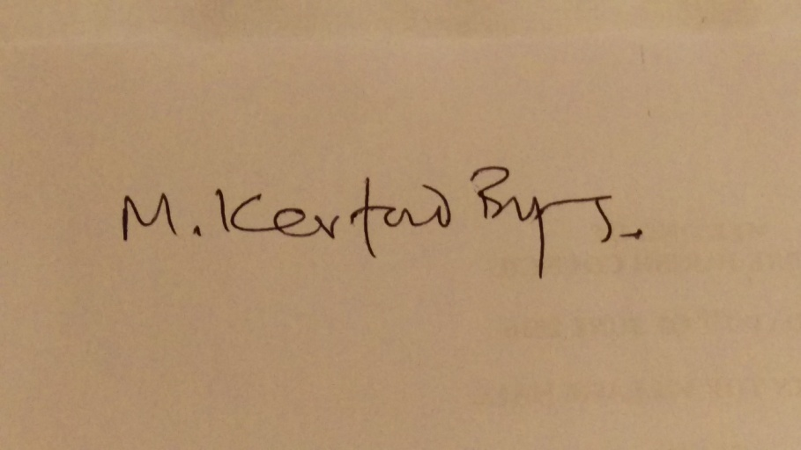
The date of the next meeting is to be September 1st. Meeting closed at 21.02.

CORRESPONDENCE CIRCULATED
Clerks and Councils Direct July 2020 – SC to take to MKB

